Spark
Apache Spark is a general purpose cluster computing system for large scale data processing
Spark has APIs in java, scala, python and R
The main API’s in spark are:
1) Spark SQL
2) Spark Streaming
3) Mllib
4)GraphX

Spark Abstraction and Concepts
- RDD are an immutable collection of elements that are found partitioned across nodes
- DAG is a mathematical construct that is commonly used to represent data flows and dependencies.
- Spark Context is an application instance which represent the connection between master and spark cluster. It also helps create us RDD, broadcast variables and accumulators.
- Transformations are set of operations on RDD and create another RDD, e.g map, filter
- Actions are a set of operations on RDD and returns non RDD, e.g groupBy, reduceBy

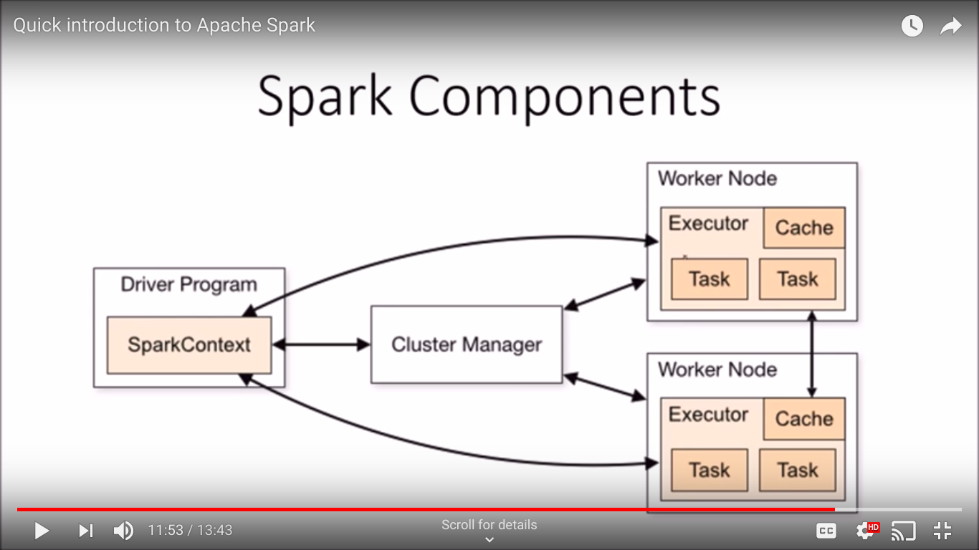
Spark Components

